How to get the Subject Key Identifier (SKI) from your CAC:

- Make sure that CAC is inserted into machine
- Press Windows + R
- Run will open:
- In the box that says open, type certmgr.msc
- Then click “OK”
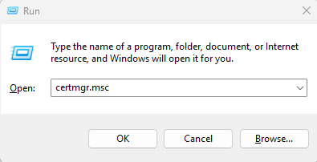
- A user account control box will pop up that asks if the program can make changes. Click “Yes”
- Your certmgr.msc screen should look like this: 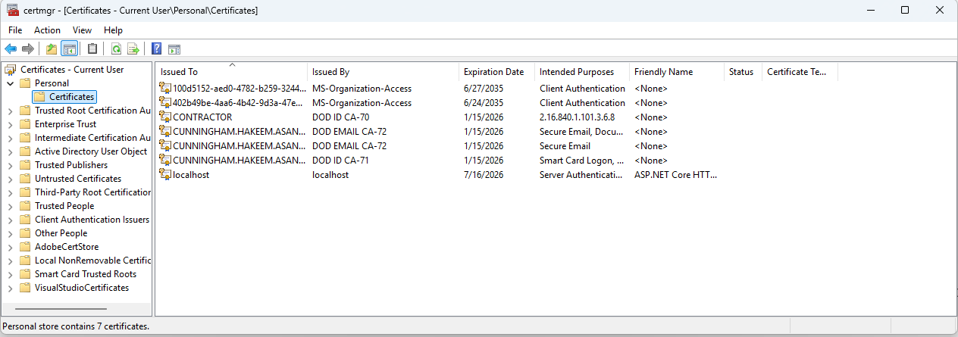
- Click the “Personal” folder Then click the “Certificates folder
- Double click on the certificate that says “Smart Card Logon” under the Intended Purposes column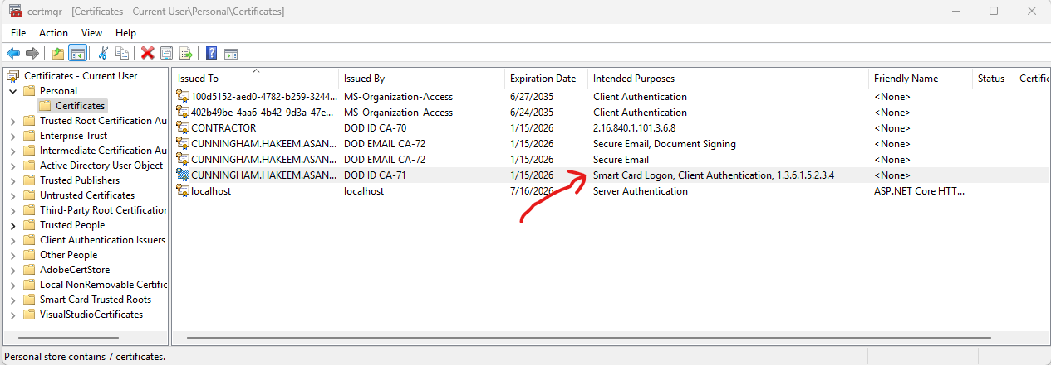
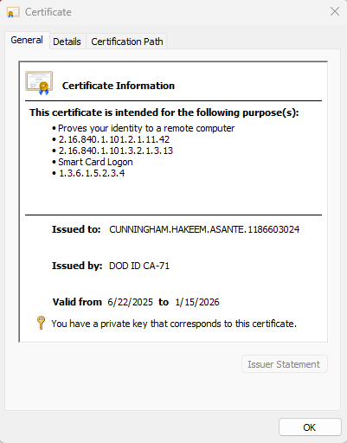
- Click the “Details” tab and scroll down to the field that says “Subject Key Identifier”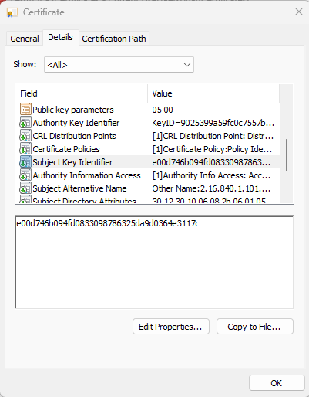
- Highlight the value in the lower box and Copy (Ctrl + C) and paste that value in your email
